**Simulation of Preemptive Process Scheduling Algorithms**

**LAB # 11**



**Spring 2023**

**CSE-204L Operating Systems Lab**

Submitted by: **Ali Asghar**

Registration No.: **21PWCSE2059**

Class Section: **C**

“On my honor, as student of University of Engineering and Technology, I have neither given nor received unauthorized assistance on this academic work.”

Submitted to:

**Engr. Madiha Sher**

Date:

**26th June 2023**

**Department of Computer Systems Engineering**

**University of Engineering and Technology, Peshawar**

**IMPLEMENT THE ROUND-ROBIN SCHEDULING ALGORITHM.**

**PURPOSE:**

A Round Robin Scheduler algorithm is designed especially for time sharing systems. It is similar to FCFS scheduling but preemption is added to switch between processes

Preemption: The act of interrupting a currently running task in order to give time to another task.

**DESCRIPTION:**

To implement Round robin scheduling we keep the ready queue as a FIFO queue of processes. New processes are added to the tail of the ready queue. The CPU scheduler picks the first process from the ready queue, sets a **timer to interrupt** after one time quantum and dispatches the process. A small unit of time called a time quantum or time slice is defined. A time quantum is generally from 10 to 100 milliseconds.

The process may have CPU burst of less than one time quantum. In this case the process itself will release the CPU voluntarily .The scheduler will then proceed to the next process in the ready queue. Otherwise if the CPU burst of the currently running process is longer than 1 time quantum, the timer will go off and will cause an interrupt to the operating system. The average waiting time under Round Robin policy is how ever quite long.

**Task 1: Take Arrival Time = 0 and Burst Time = Multiple of 5.**

**Code:**

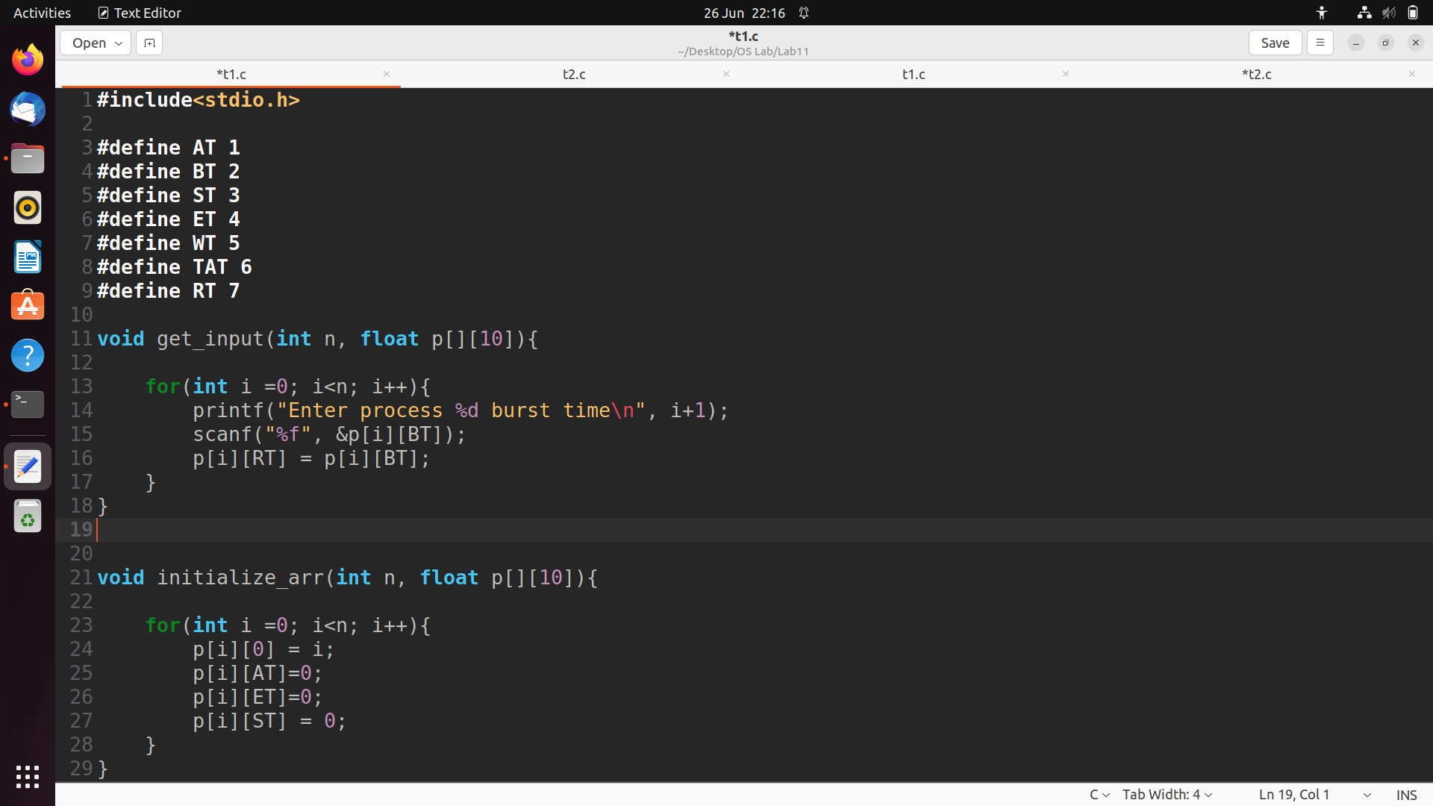

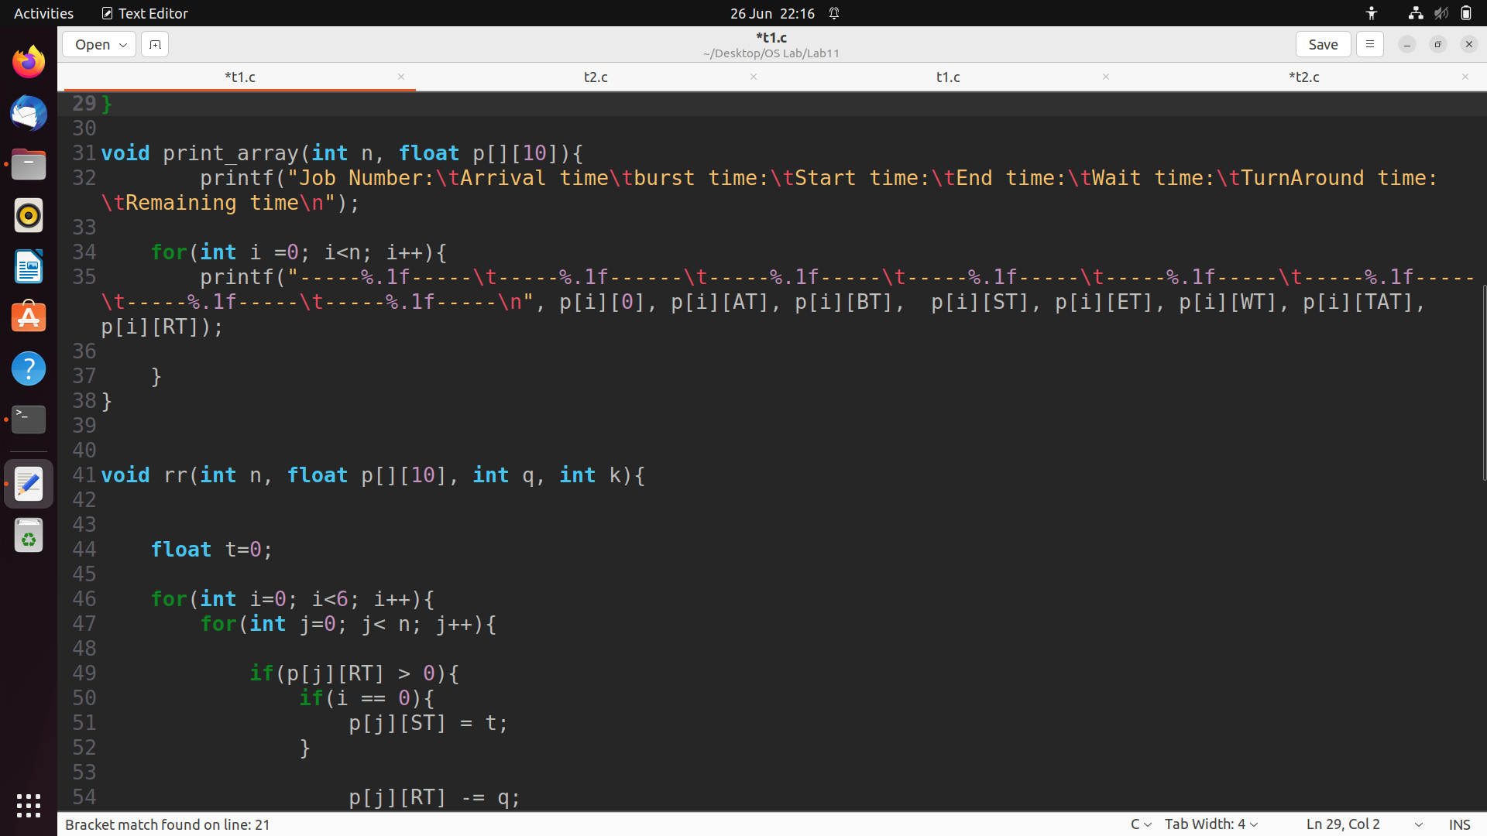

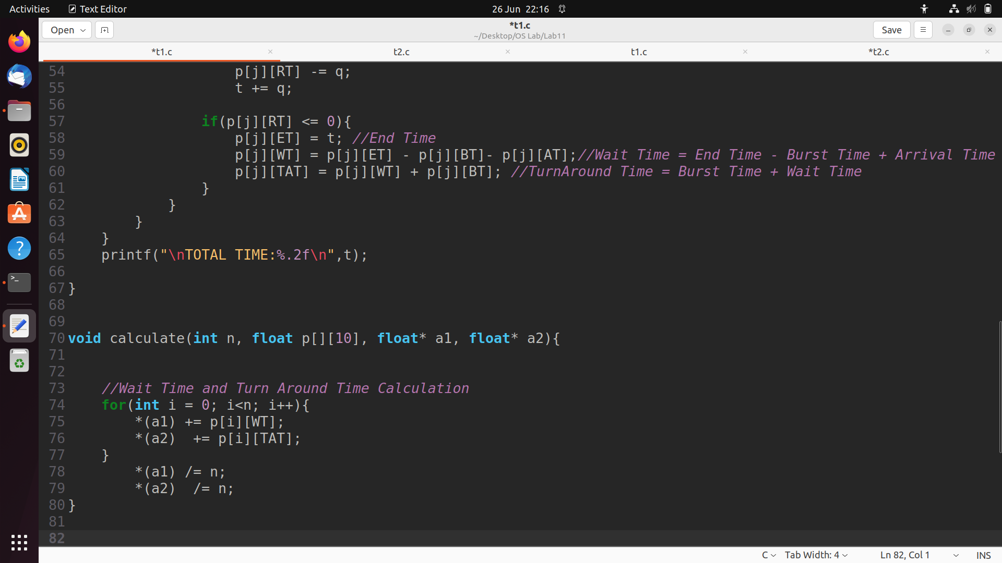

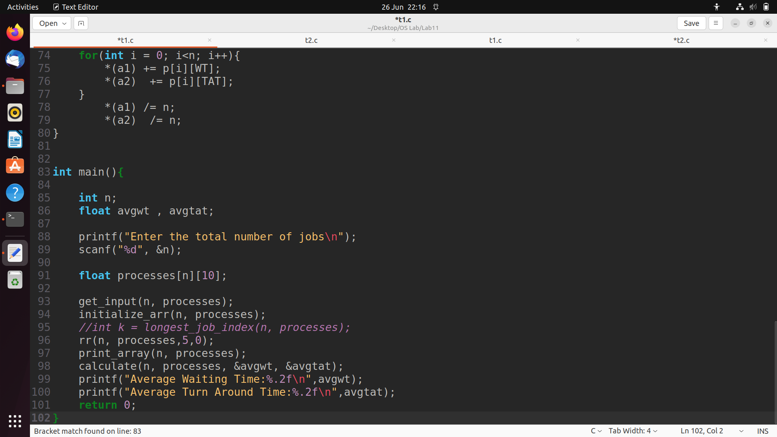

**Output:**

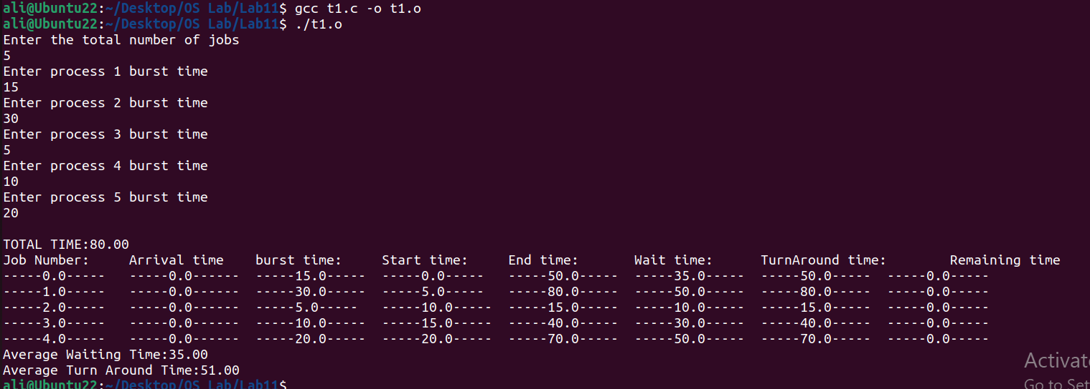

**Task 2: Take Arrival Time other than 0 and Burst Time other than Multiple of 5.**

**Code:**

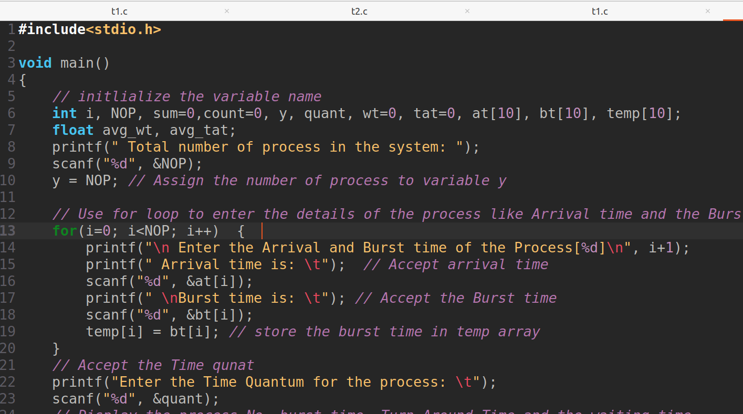

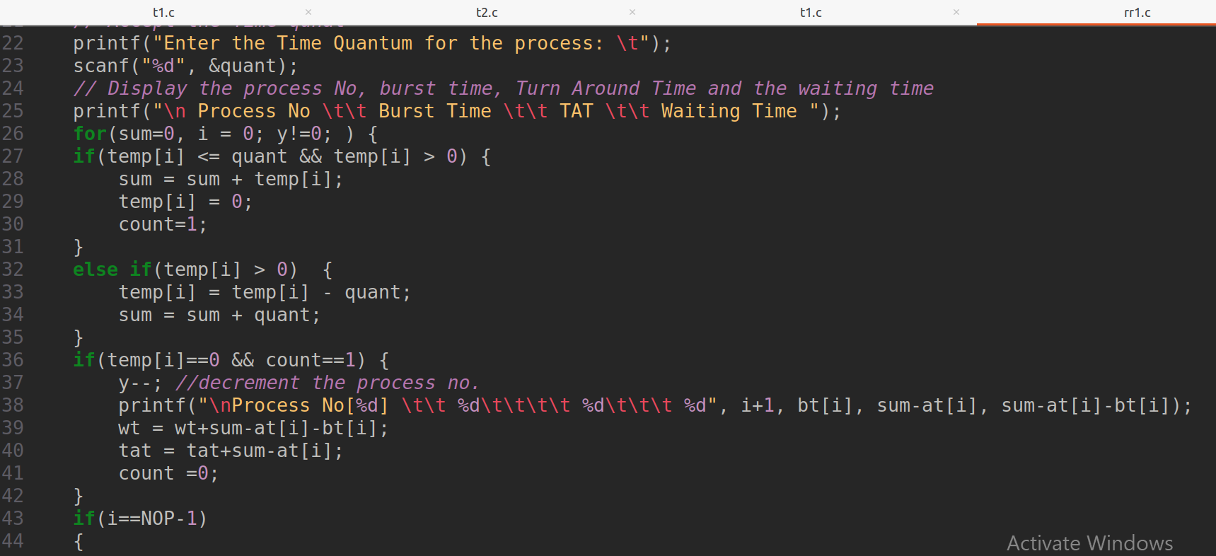

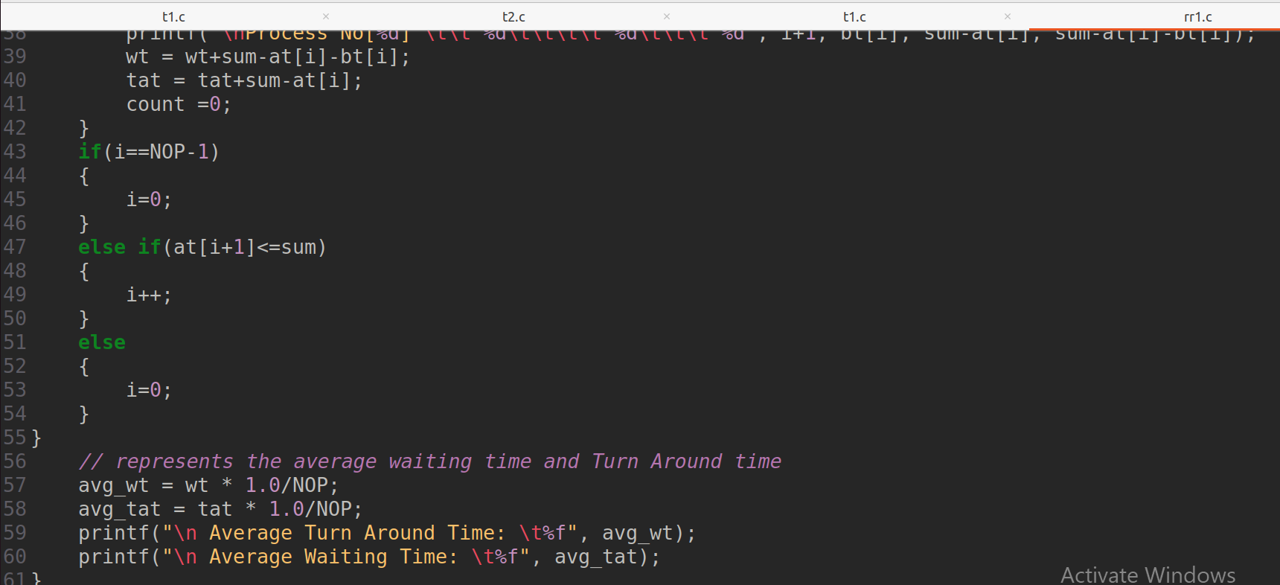

**Output:**

